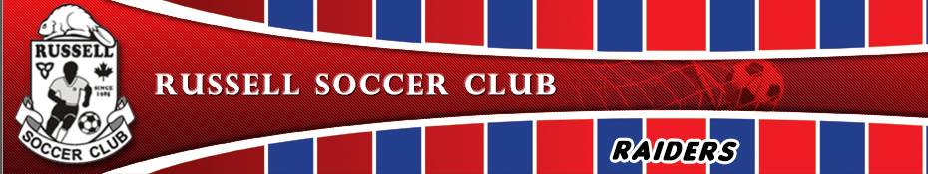
Russell soccer club is currently accepting registrations for our Raiders and House league programs for this coming spring / summer !
Why join Russell Soccer Club:
- Established club with a proud history in Our local community;
- We offer both competitive (Raiders teams) and recreational programs for all ages;
- Friendly club with extremely affordable rates.
Our Raiders teams offer:
- Competitive level soccer starting at Under 9’s (Grade 3) for both boys and girls;
- NCCP certified coaches;
- Outstanding soccer facilities here in Russell;
- A schedule that is less demanding than other competitive sports, allowing for family time over the summer months;
- Play with your friends from school, as our Club attract youths from our own community;
- Year round soccer for those interested at our Amazing new Dome !
Our Raiders teams are currently looking for players with above average skill level who are keen to learn and develop their soccer skills in a fun, challenging environment!
GO RAIDERS !
For those interested in playing at a recreational level, our hugely popular House league program offers Soccer with friends from your local community and local schools in a fun environment !
Please visit www.russellsoccer.com, or contact our club Admin at rsclub@russellsoccer.com for further questions. We look forward to seeing you at Russell Soccer Club !

